# **Software Project Management Plan**

## **Problem Definition**

* 1. **Name of this Capstone Project**
* Official name: **Discovery Year (DY) Emergency Response.**
* Vietnamese name: hệ thống thông báo khẩn cấp.
* Abbreviation: DYER.
  1. **Problem Abstract**

Nowadays, many educational institutions conduct activities that involve students going abroad their home countries such as student exchange programs, internships and so on. The number of students going abroad keeps increasing every year and it is getting increasingly more difficult for their home institutions to be able to regularly keep in contact with them while overseas. This situation creates a demand for a tool to facilitate a more efficient way to communicate with them, either for messaging or for alerting them of any events. It is also within the authorities’ goal to ensure that those students are alerted of any potential dangers or emergency situations in their host countries.

* 1. **Project Overview**
     1. **Current Situation**

Some problems encountered in this project.

The Discovery Year Coordinators are unable to cope with the number of students they have manage manually. All communications with the students are via WhatsApp, Messenger, Gmail, etc. It takes a while for students to respond back or at all.

* + 1. **The Proposed System**

The proposed system is an emergency response system. This system contains a website application for Admin and DYC from different faculty in the school. And the mobile applications for students and both Admin and DYC.

In details, the system provides following features:

**For students:**

* All DY Students (local/abroad) can log in to this application.
* The account will be expired in the end of DY time.
* See basic information of host organization they will come.
* Give report in case emergency.
* Log in one time.
* Receive notification from their teacher.
* Give answer about their status.
* Student can see their tip-line.
* Update new phone number in new country.
* Submit their recent coordinates by click “emergency button”.

**For DYC:**

* Log into web application.
* Log into mobile application one time.
* List of their students for each host organization by country.
* Only can see information of student inside their faculty.
* Create notification to group of student.
* See number of students answered and list of them (OK/NOT OK).
* See number of students not answered and list of them.
* Receive notification from Admin.
* Import student information form Excel file.

**For Admin:**

* Log into web application.
* Log into mobile application one time.
* View report.
* Create notification for student and DYC.
* List of their students for each host organization by country.
* Manage account and information of DYC and Students: create, edit, activate or deactivate.
* Manage country and host organization: create, edit, activate or deactivate.
  + 1. **Boundaries of the System**

The system works under the assumption that the user’s device has an active internet connection.

**The system can:**

* Allow DYC know list of their faculty’s students and the country they go abroad.
* Allow Admin and DYC to send the notification to student’s device.
* Allow Admin to manage DYC’s staff and student abroad and host organization.
* Allow DYC quickly know about their student’s status in case emergency.
* Allow Admin to see the report from DYC.

**The system cannot:**

* Run without internet connection and database.
  + 1. **Future Plan**

In the future, we want to upgrade and develop the system with following features:

* Support Malaysian languages.
* Admin can see the location of student on Google map.
* Admin and DYC can chat with their student.
* Can handle with more than 1000 students.
* Can know the last location of student in case no internet connection.
  1. **Development Environment**

#### **Hardware Requirements**

|  |  |  |
| --- | --- | --- |
| **Server** | **Minimum Requirements** | **Recommended** |
| **Internet Connection** | Cable (4 Mbps) | Cable (8 Mbps) |
| **Operating System** | Window Server 2008 | Window Server 2008 |
| **Computer Processor** | Intel® Xeon ® 1.4GHz | Intel® Xeon ® Quad Core (12M Cache, 2.50 GHz) |
| **Computer Memory** | 4GB RAM | 8GB or more |

Table 1. Hardware requirements for server

|  |  |  |
| --- | --- | --- |
| **PC** | **Minimum Requirements** | **Recommended** |
| **Internet Connection** | Cable, Wi-Fi (4 Mbps) | Cable, Wi-Fi (8 Mbps) |
| **Operating System** | Window 7 | Window 7 or more. |
| **Computer Processor** | Intel® Core i3 1.4GHz | Intel® Core i5 2.50GHz |
| **Computer Memory** | 1GB RAM | 2GB RAM or more |
| **Web Browser** | Firefox (v52 or higher), Chromes (v28 or higher) | Chrome latest stable version |

Table 2. Hardware requirements for PC

|  |  |  |
| --- | --- | --- |
| **Mobile Phone** | **Minimum Requirements** | **Recommended** |
| **Internet Connection** | Wi-Fi (4 Mbps) | Wi-Fi (8 Mbps) |
| **Operating System** | Android, IOS | Android, IOS lates verison |
| **Phone Memory** | 1GB RAM | 2GB RAM or more |

Table 3. Hardware requirements for Mobile Phone

#### **Software Requirements**

|  |  |  |
| --- | --- | --- |
| **Software** | **Name/ Version** | **Description** |
| **Operating System** | Windows 8 or above | Operating system and platform for development |
| **IDE** | Visual Studio 2017 | Used for implementing website and phone mobile |
| **Design Model Tool** | StarUML v2.5.1 | Used for creating model and diagram |
| **Design UI Tool** | Adobe XD | Used for create UI prototype |
| **DBMS** | SQL Server 2014 | Used for creating & managing database |
| **Document storage** | Google Drive | Used for storing documents |
| **Store and manage source code** | Github with Source Tree | Used for storing source code |
| **Communication** | Facebook, Whatsapp, Email, | Used for exchanging information, online meeting, communication |
| **Web browser** | Chrome 28 or higher | Testing browser |
| **Mobile Phone** | Iphone SE, Sony Phone | Testing mobile application |

Table 4. Software requirements

1. **Project Organization**
2. **Software Process Model**

In this project, our team choose Scrum, an Agile framework that allows us to set up a plan step by step To maximize success. We chose this model because of the following reasons:

* Time-saving: daily meetings ensure that the process is at correct stage, as established at the beginning of the project.
* Easy to use: suitable model for small and medium project.
* Fast response to changes: product owner may change requirements or extend / reduce scope and we can adapt better right on time.
* Encourage teamwork: roles and tasks are divided and assigned efficiently.
* Functional tests are frequent in the entire process.

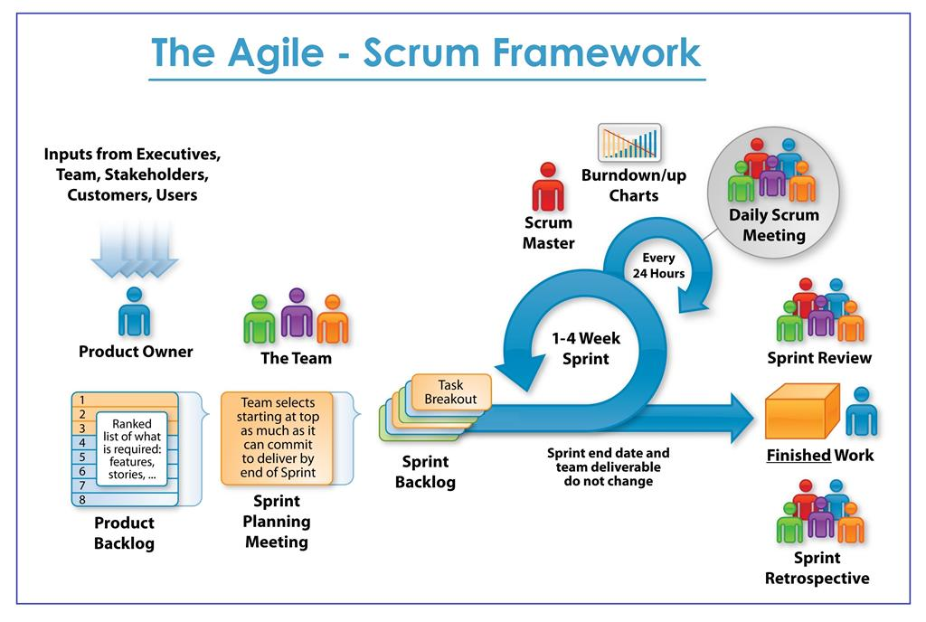

*Figure 1. Scrum Framework*

1. **Roles and Responsibilities.**

|  |  |  |  |
| --- | --- | --- | --- |
| **No.** | **Full name** | **Role in Group** | **Responsibilities** |
| 1 | Ngô Đăng Hà An | Supervisor,  Product owner | * Specify user requirements * Control the development process * Support in technique and business logic. |
| 2. | Ngô Thục Thiên Bình | Team Leader,  BA,  Developer,  Tester | * Manage process * Plan Scrum implementations * Clarify requirements * Design database * Code on Web Application * Write document and report * Test * Contact with client * Research technology * Design GUI Website * Provide API for Mobile |
| 3. | Mohammad Firdaus bin Haji Jais | Team member,  Developer,  Tester | * Clarify requirements * Design database * Code Web Application * Write document and report * Test * Contact with client * Research technology * Design GUI Website * Provide API for Mobile |
| 4. | Phạm Thị Xuân Hạ | Team member,  Developer,  Tester | * Design GUI Mobile * Clarify requirements * Design database * Code on Mobile Application * Test * Create test plan * Write document and report * Research technology |
| 5. | Muhd. Wafi Nur Arif bin Shamdi | Team member,  Developer,  Tester | * Design GUI Mobile * Clarify requirements * Design database * Code on Mobile Application * Test * Write document and report * Research technology |
| 6. | Hoàng Nhựt Vũ | Team member,  Developer,  Tester | * Design GUI Mobile * Clarify requirements * Design database * Code on Mobile Application * Test * Write document and report * Research technology |

*Table 5. Roles and responsibilities details*

1. **Tools and Techniques.**

|  |  |
| --- | --- |
| **Tool/Technique** | **Name/Version** |
| Front-end | HTML5, CSS3, Bootstrap, Javascript/jQuery, AdminLTE |
| Back-end | C#, .NET Framework |
| Managing Database | Microsoft® SQL Server® 2014 Management Studio |
| Source Control | Sourcetree (server github.com) |
| Modeling Tool | StarUML v2.8.1 |
| Web Browser | Google Chrome |
| Mobile Application | Xamarin Cross-Platform/ lates version |
| Mobile Phone | Iphone, Android phone |

Table 6. Tools and techniques

## **Project Management Plan**

1. **Product Backlog**

|  |  |  |  |  |
| --- | --- | --- | --- | --- |
| **Story**  **ID** | **Features** | **Task**  **ID** | **Task description** | **Sprint** |
| 1 | Create Product Backlog | 1.1 | Create product backlog | 1 |
| 2 | Create Introduction document | 2.1 | Create introduction document | 1 |
| 2.2 | Review introduction document | 1 |
| 3 | Learning Xamarin | 3.1 | Learning Xamarin Cross-Platform | 1 |
| Learning MVC API, Entity Framework | 3.2 | Learning MVC API, Entity Framework | 1 |
| Learning Firebase Push Notification | 3.3 | Learning Firebase Technology | 1 |
| 4 | Create UI mockups | 4.1 | Search for suitable UI | 2 |
| 4.2 | Login Mobile UI | 2 |
| 4.3 | Admin Mobile UI | 2 |
| 4.4 | DYC Mobile UI | 2 |
| 4.5 | Student Mobile UI | 2 |
| 4.6 | Login Website UI | 2 |
| 4.7 | Admin Website UI | 2 |
| 4.8 | DYC Website UI | 2 |
| 5 | Create Software Project Management Plan | 5.1 | Problem definition | 2 |
| 5.2 | Project organization | 2 |
| 5.3 | Project management plan | 2 |
| 5.4 | Coding convention | 2 |
| 6 | Create Software Requirement Specifications | 6.1 | User requirement specification | 2 |
| 6.2 | External interface requirement | 2 |
| 6.3 | Use case diagram | 3 |
| 6.4 | Software system attributes | 2 |
| 6.5 | Database diagram | 2 |
| 7 | Create Software Design Description | 7.1 | Design overview | 3 |
| 7.2 | System architectural design | 3 |
| 7.3 | Component diagram | 3 |
| 7.4 | Detailed description of components | 3 |
| 7.5 | Sequence diagram | 3 |
| 7.6 | User interface design | 2 |
| 7.7 | Database design | 3 |
| 7.8 | Coding | 3 to 6 |
| 8 | Create Software Test Documentation | 8.1 | Test Plan | 5 |
| 8.2 | Test Cases | 5 |
| 8.3 | Checklists | 6 |
| 9 | Software User’s Manual | 9.1 | Installation Guide | 6 |
| 9.2 | User’s Guide | 6 |

Table 7. Product backlog

1. **Deliverables**

|  |  |  |  |  |
| --- | --- | --- | --- | --- |
| **No** | **Deliverable** | **Delivery date** | **Delivery location** | **Note** |
| 1 | Introduction Document, Task list | 13/10/2018 | Supervisor’s office | Report No.1 |
| 2 | Software Project Management Plan | 13/10/2018 | Supervisor’s office | Report No.2 |
| 3 | Software Requirements Specification | 20/10/2018 | Supervisor’s office | Report No.3 |
| 4 | Software Design Description | 30/10/2018 | Supervisor’s office | Report No.4 |
| 5 | Software Test Documentation Guide Implementation (Coding) | 10/11/2018 | Supervisor’s office | Report No.5 |
| 6 | Software User’s Manual | 20/11/2018 | Supervisor’s office | Report No.6 |

Table 8. Deliverables

* For each sprint, deliverables are potentially shippable products, which can be a part of documents or runnable software application which is implementation of some program features.

* Each sprint is completed in 1 week.

## **Coding Convention**

* **Naming conventions:**
  + Use pascal case for class names and method names.
  + Use camel case for method arguments and local variables.
  + Do not use underscore in identifiers. Except: prefix private static variables with an underscore.
  + Use noun or noun phrases to name a class.
  + Prefix interfaces with letter ‘I’.
* **Layout conventions:**
  + Tabs must be set exactly 4 spaces.
  + Avoid lines longer than 80 characters.
  + Vertically align curly brackets.
  + Write only one statement per line.
  + Write only one declaration per line.
  + Add one blank line between method definitions and property definitions.
* **Declaration:**
  + Use implicit type ‘var’ for local variable declarations. Except: primitive types (int, string, double, etc.) use predefined names.
  + Organize namespaces with a clearly defined structure.
* **Commenting conventions:**
  + Place comment on a separate line.
  + Begin comment text with an uppercase letter and end with a period.
  + Add one space between comment delimiter (//) and comment text.